Program Structure

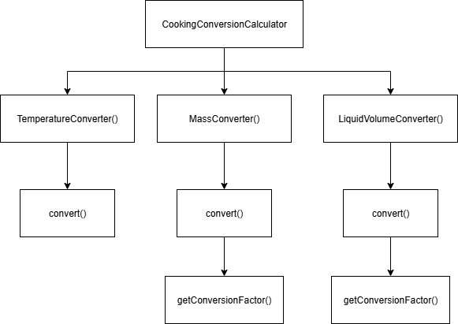

Top-down Integration
Unit under test | List of Stubs/Drivers | result | Stub’s return value | Expected results | Actual results | Pass/Fail/No run
CookingConversionCalculator | Stubs: TemperatureConverter() | ทดสอบการเรียกใช้ TemperatureConverter() | Return 1 | 1 | 1 | Pass
CookingConversionCalculator | Stubs: MassConverter() | ทดสอบการเรียกใช้ MassConverter() | Return 2 | 2 | 2 | Pass
CookingConversionCalculator | Stubs: LiquidVolumeConverter() | ทดสอบการเรียกใช้ LiquidVolumeConverter() | Return 3 | 3 | 3 | Pass
TemperatureConverter() | - | ทดสอบการเรียกใช้ TemperatureConverter()  77 f -> 25 c | - | 25 | 0 | Fail
MassConverter.convert() | Stubs: getConversionFactor() | ทดสอบการเรียกใช้ getConversionFactor()  2 cup -> 250 gram | multiplier = 125 | 250 | 250 | Pass
MassConverter.getConversionFactor() | - | 2 cup -> 250 gram | - | 250 | 250 | Pass
LiquidVolumeConverter.getConversionFactor() | Stubs: getConversionFactor() | ทดสอบการเรียกใช้ getConversionFactor()  2 cup -> 500 ml | multiplier = 250 | 500 | 500 | Pass
LiquidVolumeConverter.getConversionFactor() | - | 2 cup -> 500 ml | - | 500 | 500 | Pass

Bottom-up Integration
Unit under test | List of Stubs/Drivers | result | Stub’s return value | Expected results | Actual results | Pass/Fail/No run
TemperatureConverter() | Drivers: CookingConversionCalculator() | 77 f -> 25 c | - | 25 | 0 | Fail
MassConverter.getConversionFactor() | MassConverter.convert() | 2 cup -> 250 gram | - | 250 | 250 | Pass
MassConverter.convert() | Drivers: CookingConversionCalculator | 2 cup -> 250 gram | - | 250 | 250 | Pass
LiquidVolumeConverter.getConversionFactor() | Drivers: LiquidVolumeConverter.convert() | 2 cup -> 500 ml | - | 500 | 500 | Pass
LiquidVolumeConverter.convert() | Drivers: CookingConversionCalculator | 2 cup -> 500 ml | - | 500 | 500 | Pass
CookingConversionCalculator | - | 5 tablespoon -> 40 gram | - | 40 | 40 | Pass

